|  |
| --- |
| Ricky Ramnath |

Humber College Parts Crib Management Solution

Status

/1 Hardware present?

/1 Title Page

/1 Declaration of Joint Authorship

/1 Proposal (500 words)

/1 Executive Summary

# Declaration of Joint Authorship

We, Student A, Student B, and Student C, confirm that this work submitted is the joint work of our group and is expressed our own words. Any uses made within it of the works of any other author, in any form (ideas, equations, figures, texts, tables, programs), are properly acknowledged at the point of use. A list of the references used is included. The work breakdown is as follows: Each of us provided functioning, documented hardware for a sensor or effector. Student A provided RFID Scanner. Student B provided GPS Sensor. Student C provided 12- Button Keypad. In the integration effort Student A is the lead for further development of our mobile application, Student B is the lead for the Hardware, and Student C is the lead for connecting the two via the Database.

# Proposal

We have created a mobile application, worked with databases, completed a software engineering course, and prototyped a small embedded system with a custom PCB as well as an enclosure (3D printed/laser cut). Our Internet of Things (IoT) capstone project uses a distributed computing model of a smart phone application, a database accessible via the internet, an enterprise wireless (capable of storing certificates) connected embedded system prototype with a custom PCB as well as an enclosure (3D printed/laser cut), and are documented via this technical report targeting OACETT certification guidelines.

Intended project key component descriptions and part numbers  
Development platform:   
Sensor/Effector 1: RFID Scanner  
Sensor/Effector 2: GPS Sensor  
Sensor/Effector 3: 12 Button Keypad

We will continue to develop skills to configure operating systems, networks, and embedded systems using these key components to create an easier and more efficient method for allowing students to borrow parts from The Parts Crib. This project consists of both a web application and a mobile application with our sensors/effectors. The mobile application provides convenient access for students. This will be beneficial to students as they will be able to utilize the app to find parts that are available. They will be able to view the inventory of available parts which they can borrow if they wish, by using their student credentials. The web application will be utilized mainly by administrative users to keep track of inventory. The overall goal of this project is to avoid overcrowding in The Parts Crib during peak hours of the lab, keep track of parts that have yet to be returned by certain students based on their student credentials and to keep track of the remaining inventory. The RFID Scanner will be used to scan in and out parts that will be recorded on the online database which helps to provide inventory status. The GPS Sensor will prioritize the orders by location and help to identify a more specific location for The Parts Crib. The 12 Button Keypad will be used to get new registered users to type in a specific randomly generated code into the application upon registration to verify that they identify as a Humber College Student.

Our project description/specifications will be reviewed by, _____, ideally an employer in a position to potentially hire once we graduate. They will also ideally attend the ICT Capstone Expo to see the outcome and be eligible to apply for NSERC funded extension projects. This typically means that they are from a Canadian company that has been revenue generating for a minimum of two years and have a minimum of two full time employees.

The small physical prototypes that we build are to be small and safe enough to be brought to class every week as well as be worked on at home. In alignment with the space below the tray in the Humber North Campus Electronics Parts kit the overall project maximum dimensions are 12 13/16" x 6" x 2 7/8" = 32.5cm x 15.25cm x 7.25cm.

Keeping safety and Z462 in mind, the highest AC voltage that will be used is 16Vrms from a wall adapter from which +/- 15V or as high as 45 VDC can be obtained. Maximum power consumption will not exceed 20 Watts. We are working with prototypes and that prototypes are not to be left powered unattended despite the connectivity that we develop.

# Executive Summary

Explain what accomplishments are described by this document and why your product should be purchased and you should be hired by an investor.

Contents

Declaration of Joint Authorship 3

Proposal 5

Executive Summary 9

List of Figures 13

1.0 Introduction 15

1.1 Scope and Requirements 16

2.0 Background 17

3.0 Methodology 19

3.1 Required Resources 19

3.1.1 Parts, Components, Materials 19

3.1.2 Manufacturing 19

3.1.3 Tools and Facilities 19

3.1.4 Shipping, duty, taxes 19

3.1.5 Time expenditure 19

3.2 Development Platform 19

3.2.1 Mobile Application 19

3.2.2 Image/firmware 21

3.2.3 Breadboard/Independent PCBs 21

3.2.4 Printed Circuit Board 23

3.2.5 Enclosure 24

3.3 Integration 25

3.3.1 Enterprise Wireless Connectivity 26

3.3.2 Database Configuration 26

3.3.3 Security 26

3.3.4 Testing 26

4.0 Results and Discussions 27

5.0 Conclusions 29

6.0 References 31

7.0 Appendix 33

7.1 Firmware code 33

7.2 Application code 33

# List of Figures

Figure 1. By Android Studio - https://developer.android.com/studio/, CC BY-SA 4.0, https://commons.wikimedia.org/w/index.php?curid=74094999 21

Figure 2. Initial schematic. This work is a derivative of "http://fritzing.org/parts/" by Fritzing, used under CC:BY-SA 3.0. 22

Figure 3. This work is a derivative of "http://fritzing.org/parts/" by Fritzing, used under CC:BY-SA 3.0. 22

Figure 4. Breadboard prototype. 23

Figure 5. PCB design This work is a derivative of "http://fritzing.org/parts/" by Fritzing, used under CC:BY-SA 3.0. 24

Figure 6. Humber Sense Hat Prototype PCB. 24

Figure 7. Example enclosure. 25

# 1.0 Introduction

This technical report presents the methods and processes of how we achieved our project result. Knowing who arrives, borrows parts and having easy access to our inventory are key parts of the parts crib management solution. Some of this projects policy require that you track how long students are borrowing parts for or that all students participating return each part at a certain time of day that is specified. This will additionally be able to help the administrative side by verifying that individuals borrowing parts are Humber College students that have an official student ID card. By recording sign-out times, it’s easy to track who borrows parts when and attend to students who are over their time limit or that have not yet returned said parts. Having a GPS sensor to track activity from a certain parts crib location and prioritize orders will also help with an efficient way of managing the parts crib. To further enhance security, the keypad will allow students to enter the specific code that will be generated by the application to ensure verification of Humber students. Finally, the RFID scanner will be a critical component of this project to help keep track of inventory by uploading information to the database for a more accurate count and to easily monitor activity. The application will provide a precise GPS location of the parts cribs, inventory status, and peak times for labs. The application will also allow students to create a cart of parts they will need for their labs and place orders from anywhere with a Wi-Fi connection. This system is meant for loan out companies and small businesses with inventory that will need to be loaned out to employees or customers. Specifically, this system will be prototyped and used by the Humber College Parts Crib.

## 1.1 Scope and Requirements

The parts crib management system will implement a system that will allow the parts crib to keep an electronic catalogue of items loaned out to students. Students will be able to use a mobile android-based application to see what items are available and to request them using their student credentials. An RFID Scanner, GPS Sensor, and a Keypad

System will allow us to achieve this. Our goal is to make this a more efficient and easier way of borrowing parts from the parts crib. It is a goal of our group to make this project industry worthy for any application. We are assuming we’re capable of putting RFID tags on everyone’s student ID in the parts management system. We can also assume that the inventory of the parts crib is given to us so we’re able to put it into our database for when it comes to distribution of parts. We’re dependent on the Admins at the parts crib to be able to read the system and be able to handle the intake of item requests given to them by the users.

/1 Hardware present?

/1 Introduction (500 words)

/1 Scope and Requirements

/1 Background (500 words)

/1 References

# 2.0 Background

The Humber College Parts Crib is located in a hallway in the J building at Humber College, it’s situated near the main series of labs, as well as classrooms, used by students of the Electrical/Electronic/Computer Engineering Technology programs. The current lending system was implemented by Vlad Porcila to address issues he saw with the lending process at The Parts Crib. The system requires that students make a request on a network-connected school computer using an application. This request is then made visible in a queue of requests to Parts Crib staff. The student is then expected to come to the parts crib, present their school ID and pick up the requested parts which will have been placed in a clear bag with an RFID tag assigned to that student.

The main concerns that the Parts Crib Staff feel need to be addressed, are the amount of time spent verifying student identification, notifying students when their parts are ready to be picked up (to avoid unnecessary crowding by students who are waiting for their request to be fulfilled), a way to prioritize orders based on when a student might need the parts, and the ability to retrieve historical data.

The challenges faced by the Parts Crib are similar to those encountered when handling lending services at libraries and item tracking at logistics companies. IoT technologies are being adopted at an increasing rate in supply chain management. The key technologies being deployed are RFID tag systems, cloud computing and IoT applications allowing multiple devices to communicate with one another Ben-Daya, Hassini, Bahroun 2017). One of the most common configurations used by companies for RFID tracking of shipments is to have each RFID tag assigned to a case/pallet (Zelbst, Sower 2012. p.73). This is analogous to the bagging system currently used by The Parts Crib, and with information about the items contained in the bag being stored in a cloud database it minimizes the number of RFID tags required.

In order to limit the interaction between a student and the Parts Crib staff during the process of obtaining loan requests we will require students to have a RFID tag affixed to their Humber student ID and the web/android application will generate a 5 digit pin for each request that they’ll be required to enter after tapping their card. This system is known as a *smart card based two-factor authentication scheme* and has the advantage of being easy to scale and cost-effective (Hussain et al. 2019). As the student will return the bag using the RFID tag, the only interaction between staff and students will be the when the staff hand the designated bag of items to the students.

We would like to thank Kristian Medri, Austin Tian for providing us with support during the writing of this report as well as overseeing our work on the application/website and physical prototype and Vlad Porcilo for meeting with us during project milestones to provide further input into features The Parts Crib staff would like to see.

# 3.0 Methodology

## 3.1 Required Resources

Report

/1 Parts/components/materials (500 words)

/1 PCB, case (500 words)

/1 Tools, facilities (500 words)

/1 Shipping, duty, taxes (250 words)

/1 Working time versus lead time (250 words)

### 3.1.1 Parts, Components, Materials

There will be many parts, components, and materials that will be used in this project. Firstly, there will be the sensors which include; the radio frequency identification scanner, global position sensor, and a twelve-button keypad. Each sensor and effector will be a key asset to this project. Some materials that will be used will include, laser cut acrylic, fiberglass epoxy resin with a copper foil bonded on to one or both sides which is what the printed circuit board is made of, and acrylonitrile butadiene styrene plastic for the three-dimensional printed parts that will be used with the acrylic to make a feasible enclosure to house our sensors. For our development platform, we will be using a raspberry pi three model b as well as a nucleo STM32 microcontroller. The nucleo stm32 microcontroller will be used alongside with the twelve-button keypad and the raspberry pi 3 model b will be used to accommodate the radio frequency identification scanner, global position sensor and the nucleo STM32 microcontroller to use the twelve-button keypad. This will all be housed in the enclosure made from acrylic and acrylonitrile butadiene styrene plastic. Some extra components will be a registered jack-forty-five ethernet cable with an ethernet to universal serial bus adapter. This will allow the Broadcom development platform to connect to a laptop via a remote desktop connection to configure settings for the sensors and effector. Some additional accessories that will enhance the features of the project will include; radio frequency identification tags for attaching to parts to scan in or out for inventory control, and an external active global position sensor antenna that will allow the sensor to have a boosted signal to get a position fix more faster and efficiently. The Two-Factor authentication will be implemented using both a soft and hard entry method. The user will be able to enter the five digits on the android device when prompted or enter them manually using the physical keypad. The keypad will itself be connected to a Raspberry Pi through the proprietary universal serial bus port with the STM32 microcontroller. The radio frequency identification scanner and the global positioning sensor will both be connected to the same Raspberry Pi using its general-purpose input/output pins and will both interface with the Real-Time database which will be used to retrieve both Student Information for radio frequency identification tags and current locations from the on-board global position sensor on their phone. The radio frequency identification scanner information will already have been loaded onto the database at the time of onboarding at the parts crib while the global position sensor coordinates will be pulled from the student’s phone when appropriate. An overall combination of these parts, components, and materials will lead to a successful build and presentation of the project.

### 3.1.2 Manufacturing

### 3.1.3 Tools and Facilities

### 3.1.4 Shipping, duty, taxes

### 3.1.5 Time expenditure

Working time versus lead time.

## 3.2 Development Platform

### 3.2.1 Mobile Application

Status

/1 Hardware present?

/1 Memo by student A + How did you make your Mobile Application? (500 words)

/1 Login activity

/1 Data visualization activity

/1 Action control activity

Include screenshots such as Figure 1. Testing. Progress.

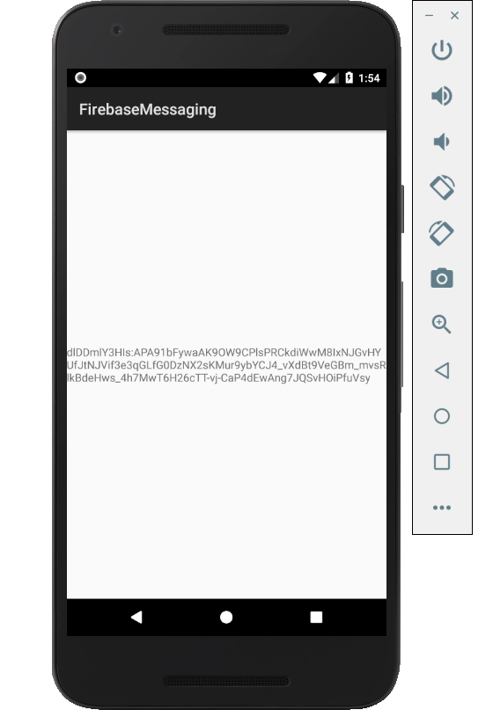

Figure 1. By Android Studio - https://developer.android.com/studio/, CC BY-SA 4.0, https://commons.wikimedia.org/w/index.php?curid=74094999

### 3.2.2 Image/firmware

Status

/1 Hardware present?

/1 Memo by student B + How did you make your Image/firmware? (500 words)

/1 Code can be run via serial or remote desktop

/1 Wireless connectivity

/1 Sensor/effector code on repository

### 3.2.3 Breadboard/Independent PCBs

Status

/1 Hardware present?

/1 Memo by student C + How did you make your hardware? (500 words)

/1 Sensor/effector 1 functional

/1 Sensor/effector 2 functional

/1 Sensor/effector 3 functional

The initial schematic design, Figure 2, based on datasheets (Bosch Sensortec, 2019) led to a breadboard layout Figure 3 that was realized Figure 4.

How did you build your Prototype: Breadboard?

Then a PCB was designed, Figure 5, and populated (Figure 6). Bill of Materials, Case, Time commitment. Testing. Progress.

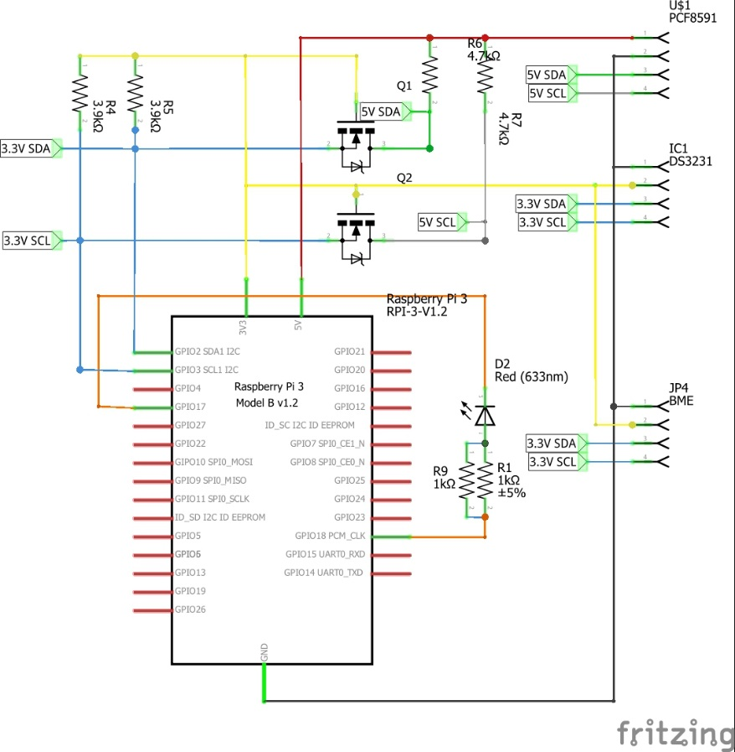

Figure 2. Initial schematic. This work is a derivative of "http://fritzing.org/parts/" by Fritzing, used under CC:BY-SA 3.0.

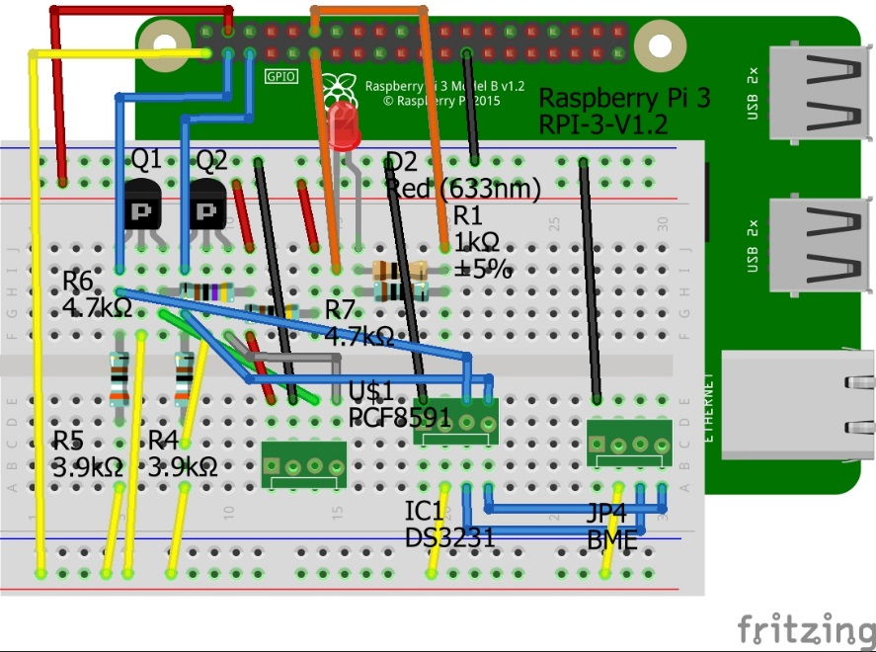

Figure 3. This work is a derivative of "http://fritzing.org/parts/" by Fritzing, used under CC:BY-SA 3.0.

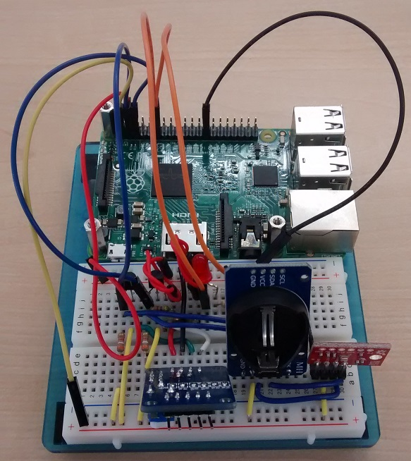

Figure 4. Breadboard prototype.

### 3.2.4 Printed Circuit Board

Demo

/1 Hardware present?

/1 PCB Complete and correct

/1 PCB Soldered wire visible but trim, no holes or vacancies

/1 PCB Tested with multimeter

/1 PCB Powered up

How did you build your Prototype: PCB?

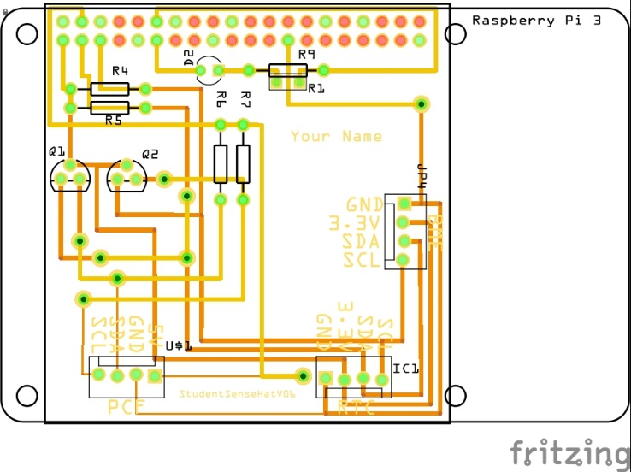

Figure 5. PCB design This work is a derivative of "http://fritzing.org/parts/" by Fritzing, used under CC:BY-SA 3.0.

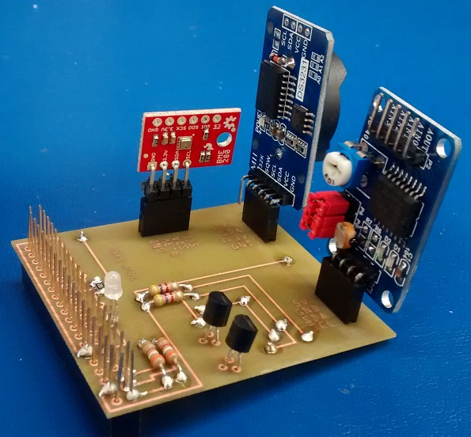

Figure 6. Humber Sense Hat Prototype PCB.

### 3.2.5 Enclosure

Demo

/1 Hardware present?

/1 Case encloses development platform and custom PCB.

/1 Appropriate parts securely attached.

/1 Appropriate parts accessible.

/1 Design file in repository, photo in report.

How did you build your Prototype: Case?

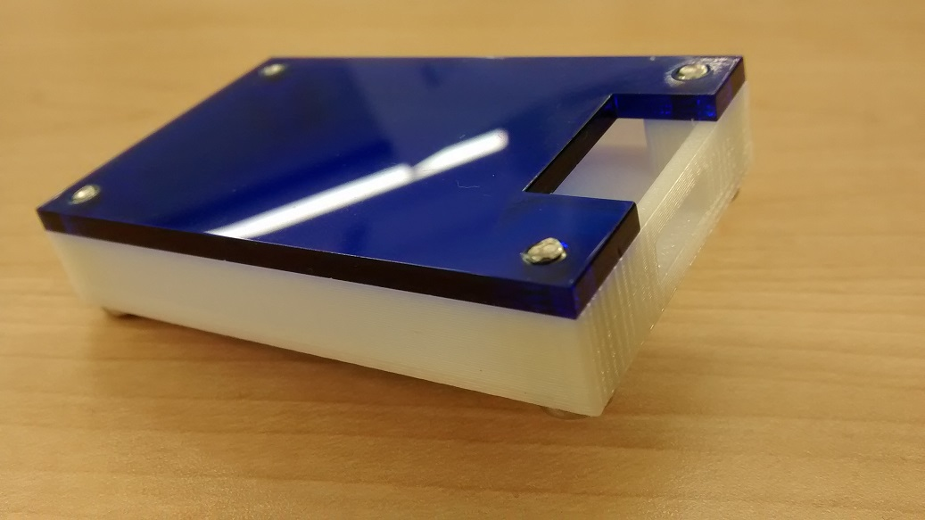

Figure 7. Example enclosure.

## 3.3 Integration

Demo

/1 Hardware present?

/1 Data sent by hardware

/1 Data retrieved by mobile application

/1 Action initiated by mobile application

/1 Action recieved by hardware

Report

/1 Enterprise wireless connectivity (250)

/1 Database configuration (250 words)

/1 Security considerations (500 words)

/1 Unit testing (900 words)

/1 Production testing (100 words)

### 3.3.1 Enterprise Wireless Connectivity

How did you make a Database accessible by both your Prototype and Mobile Application?

### 3.3.2 Database Configuration

### 3.3.3 Security

### 3.3.4 Testing

Unit testing and Production testing.

# 4.0 Results and Discussions

Is your prototype perfect? What did you learn?

# 5.0 Conclusions

If you were making 1000 of these.

Report

/1 Hardware present?

/1 Checklist truthful

/1 Valid Comments

/1 Results and Discussion (500 words)

/1 Conclusion

# 6.0 References

Tejesh, B. S. S., & Neeraja, S. (2018). Warehouse inventory management system using IoT and open source framework. Alexandria Engineering Journal, 57(4), 3817–3823. https://doi.org/10.1016/j.aej.2018.02.003

Ben-Daya, M., Hassini, E., & Bahroun, Z. (2017). Internet of things and supply chain management: a literature review. International Journal of Production Research, 57(15–16), 4719–4742. https://doi.org/10.1080/00207543.2017.1402140

Hussain, K., Jhanjhi, N., Mati-ur-Rahman, H., Hussain, J., & Islam, M. H. (2019). Using a systematic framework to critically analyze proposed smart card based two factor authentication schemes. Journal of King Saud University - Computer and Information Sciences. https://doi.org/10.1016/j.jksuci.2019.01.015

Zelbst, P., & Sower, V. (2012). RFID for the supply chain and operations professional (1st;1; ed.). US: Business Expert Press.

# 7.0 Appendix

## 7.1 Firmware code

Demo

/1 Hardware present?

/3 Code runs concurrently for all sensors/effectors

/1 Project repository contains integrated code

Status

/1 Memo including updates

/1 Financial update

/1 Progress update

/1 Modified Code Files in Appendix

/1 Link to Complete Code in Repository

## 7.2 Application code

Demo

/1 Hardware present?

/1 Memo by student A

/1 Login activity

/1 Data visualization activity

/1 Action control activity

Report

/1 Login activity

/1 Data visualization activity

/1 Action control activity

/1 Modified Code Files in Appendix

/1 Link to Complete Code in Repository